All answers must be of your own work. Type out your answers and submit your quiz through Blackboard for Quiz #2 as either a MS Word document or PDF file (Mac users using Pages, make sure to Export to MS Word).

1. (16 points, 4 points per property) In the JComboBox control, **name and describe** the purpose of four properties found in the control.

JComboBox is a drop down list that allows you to create to drop down options that can do different things based on what you code and select.

**Index**: Represented by each item list of elements in the JComboBox.

**Scroll bar**: Allows user to scroll through elements available.

**Scroll arrows**: Like the Scroll bar, it allows the user to move through the elements, each click of an arrow will display the next element in the index one at a time.

**Scroll box**: Allows the user to move through the index when selected.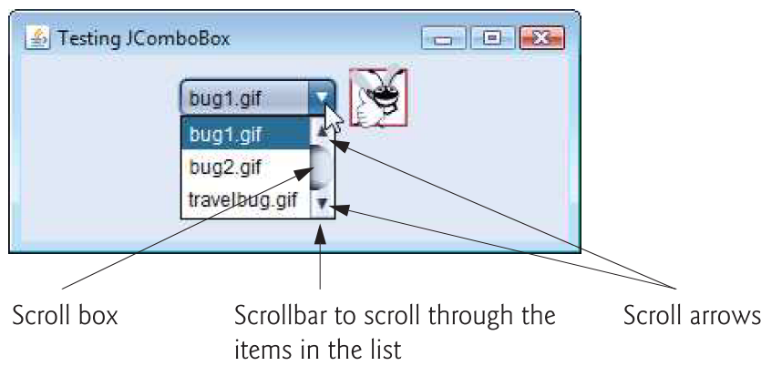

From How to Program Early Objects, 10th Edition: Fig 12.22

1. (9 points, 3 points per part) Demonstrate how we would achieve the following with the String class:
2. Retrieving the 5th character from a string named **myString** which contains the string literal “Mystery Text”, this should return the character ‘e’ in “Mystery Text”.

5th

M y s t **e** r y T e x t

1. 1 2 3 **4** 5 6 7 8 9 10 11

System.out.println(**myString**.charAt(4));

1. Demonstrate how we could use the **startsWith** method, to check to see if a string named **someString** starts with the text “in” beginning at index 2.

System.out.println(**someString**.startsWith("**in** ") );

1. Suppose we have a string named **bigString**, demonstrate how we could return the all *uppercase* substring of **bigString** with a starting index of 3 and ending index to 7.

System.out.println(**bigString**.toUpperCase(3,7 ) );